Practical Assignment 3: Neural network-based classifier

[CO1, CO3, BT: L3 (Apply)] [Max Marks: 10]

Problem Definition: Given a bank customer, build a neural network-based classifier that can determine whether they will leave or not in the next 6 months.
Dataset Description: The case study is from an open-source dataset from Kaggle. The dataset contains 10,000 sample points with 14 distinct features such as CustomerId, CreditScore, Geography, Gender, Age, Tenure, Balance, etc.
Link to the Kaggle project:
https://www.kaggle.com/barelydedicated/bank-customer-churn-modeling
Perform following steps:
1. Read the dataset.
2. Distinguish the feature and target set and divide the data set into training and test sets.
3. Normalize the train and test data.
4. Initialize and build the model. Identify the points of improvement and implement the same.
5. Print the accuracy score and confusion matrix (5 points).
Theory:
Customer Churn Prediction:
Churn refers to customers leaving a bank or company. In the banking sector, churn prediction helps in retaining valuable customers by identifying at-risk customers early.
1. Dataset Description:
The case study is from an open-source dataset from Kaggle. The dataset contains 10,000 sample points with 14 distinct features such as CustomerId, CreditScore, Geography, Gender, Age, Tenure, Balance, etc.
2. Artificial Neural Network (ANN)
An Artificial Neural Network (ANN) is a machine learning model inspired by the human brain’s structure and functioning. It is composed of layers of interconnected neurons that process data in multiple stages.
Key Components:
- Input Layer: Receives the input features.
- Hidden Layers: Perform transformations using weights, biases, and activation functions to learn complex patterns.
- Output Layer: Produces the final prediction (in churn prediction, 0 = stays, 1 = leaves).
Neuron Function: z=W⋅X + b
Where:W = weights
- X = inputs
- b = bias
The neuron applies an activation function f(z) to introduce non-linearity: a=f(z)
For binary classification, the Sigmoid function is used: σ(z)={1}/{1 + e^{-z}}

3. Keras
Keras is a high-level deep learning API written in Python that allows quick and easy building of neural networks.
It runs on top of TensorFlow and supports rapid prototyping.
Advantages:
- Simple and user-friendly syntax.
- Modular design for building networks layer-by-layer.
- Supports both CPU and GPU execution.
- Pre-built layers like Dense, Dropout, Conv2D for different types of networks.

4. TensorFlow
TensorFlow is an open-source deep learning framework developed by Google Brain.
It is a backend engine for numerical computation and deep learning model training.
Features:
- Supports large-scale machine learning.
- Automatic differentiation for gradient computation.
- Cross-platform execution: CPU, GPU, TPU.
- Works with Keras for high-level modeling.

5. Normalization
Normalization ensures that all numerical features are on a similar scale to help the model train faster and perform better. Without normalization, features with larger values dominate those with smaller values, leading to biased learning.
Common Methods:
- Min-Max Scaling:
x’= {x - x_{min}}/{x_{max} - x_{min}}
- Standardization (Z-score scaling):
x′=x−μ / σ​
Where: μ = mean of the feature and σ = standard deviation

6. Confusion Matrix
A confusion matrix is a table used to describe the performance of a classification model.
It compares predicted labels with actual labels.
For binary classification (churn prediction):
 | Predicted Stay (0) | Predicted Churn (1)
Actual Stay (0) | True Negative (TN) | False Positive (FP)
Actual Churn (1) | False Negative (FN) | True Positive (TP)
Interpretation:
- True Positive (TP): Customer churned and predicted churn.
- True Negative (TN): Customer stayed and predicted stay.
- False Positive (FP): Customer stayed but predicted churn (Type I error).
- False Negative (FN): Customer churned but predicted stay (Type II error).
Mathematical Model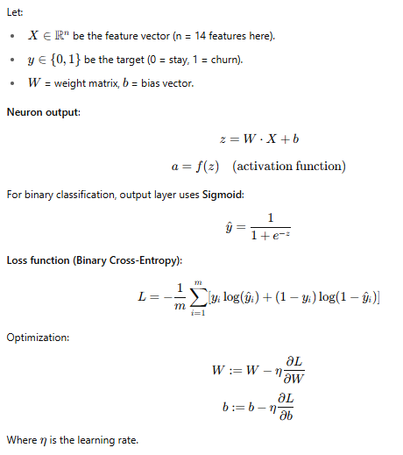
Model Evaluation Metrics:
- Accuracy: {TP + TN}/{TP + TN + FP + FN}
- Confusion Matrix: Shows TP, TN, FP, FN
- Precision: {TP}/{TP + FP}
- Recall: {TP}/{TP + FN} ​
- F1 Score: Harmonic mean of precision and recall ((2 * P*R) / (P + R))
Algorithm
- Load dataset using Pandas.
- Identify features and target variable.
- Encode categorical variables (Geography, Gender).
- Split dataset into training (80%) and testing (20%).
- Normalize numerical features using StandardScaler.
- Build a Sequential ANN model:
  - Input layer
  - Hidden layers (Dense, ReLU activation)
  - Output layer (Dense, Sigmoid activation)
- Compile model (loss = binary crossentropy, optimizer = Adam).
- Train model on training set.
- Predict on test set.
- Evaluate accuracy and confusion matrix.

Result:
(Insert Screenshots: Accuracy, Confusion Matrix, Accuracy/loss curve from Keras training)
Conclusion
The neural network-based model achieved a good accuracy ……… (Write Accuracy) in predicting bank customer churn. Feature scaling, categorical encoding, and dropout regularization helped improve performance. This model can assist banks in identifying at-risk customers early.

